PAPER TITLE
Firstname Lastname ¹, Firstname Lastname ² and Firstname Lastname ^{2,*}
¹ Affiliation 1; e-mail@e-mail.com
² Affiliation 2; e-mail@e-mail.com
* Correspondence: e-mail@e-mail.com; Tel.: (optional; include country code)

Abstract

A single paragraph of about 100 words to give a brief introduction to your work.

Keywords: Keyword 1; Keyword 2; Keyword 3

Introduction
This document contains the necessary instructions for the preparation of a two-page extended abstract for the GSAM 2026: Global Symposium on Adaptive Manufacturing to be held in Ulster University, Derry~Londonderry Campus, on September 7, 2026.
The abstract must not exceed two pages and must be written in English. These instructions and other information about the symposium can be obtained in the official website through the following: https://viram.uk/ulster-university/workshop-2

Materials and methods
The abstract must be written in English, in a single column. The abstract, including text, figures, tables, acknowledgments, and references, should not exceed a maximum of 2 pages. Abstracts that do not comply with this requirement will be forwarded to the respective authors for review.

2.1. Subsection
Insert text here.

2.1.1. Subsubsection
Insert text here.

results
All figures must be numbered sequentially and captioned as indicated. Tables must be numbered sequentially and referenced in the text, as in Table 1. More than one table or figure is allowed, but please ensure your work is explained/discussed fully within the body of the abstract. Maximum length is two single-column pages.

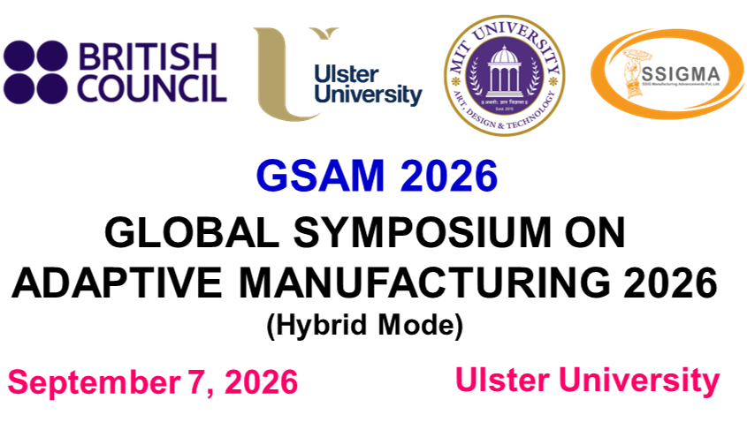
Figure 1. This is a figure.
Table 1. This is a table. Tables should be placed in the main text near to the first time they are cited.
Title 1 | Title 2 | Title 3
entry 1 | data | data
entry 2 | data | data

Discussion
Insert text here.

CONCLUSION
Insert text here.

References
References must be numbered in order of appearance in the text (including citations in tables and legends) and listed individually at the end of the manuscript.

Journals:
1. Author 1, A.B.; Author 2, C.D. Title of the article. Abbreviated Journal Name Year, Volume, page range.

Conference Proceedings:
2. Author 1, A.B.; Author 2, C.D.; Author 3, E.F. Title of Presentation. In Proceedings of the Name of the Conference, Location of Conference, Country, Date of Conference (Day Month Year).

Theses:
3. Author 1, A.B. Title of Thesis. Level of Thesis, Degree-Granting University, Location of University, Date of Completion.

Books:
4. Author 1, A.; Author 2, B. Title of the chapter. In Book Title, 2nd ed.; Editor 1, A., Editor 2, B., Eds.; Publisher: Publisher Location, Country, 2007; Volume 3, pp. 154–196.

